Sur la route - On the road

Road Route  Main road Route principale  A road Grande route - route nationale  B road Route départementale  One-way street Rue à sens unique  Street Rue  Main street Rue principale  Motorway Autoroute  Turnpike Autoroute à péage  Lane File - voie  Road map Carte routière | 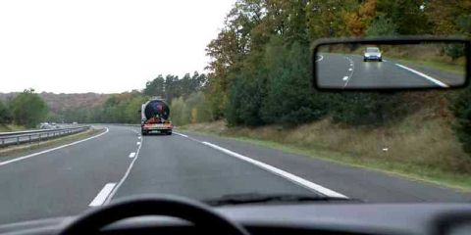
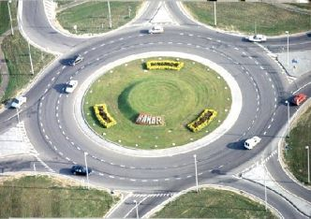 | Pavement Trottoir  Pedestrian crossing / zebra crossing Passage clouté  Central reservation Terre-plein central  Crossroads Croisement - carrefour  Junction Embranchement  Roundabout Rond-point  Bend virage
(parking) meter Parcmètre  Road sign Panneau de signalisation  Stop sign Panneau de stop  Traffic lights Feux de signalisation  Level crossing Passage à niveau  Service area Aire de service - de repos  Toll (GB)/Turnpike(US) Péage  Traffic Circulation  Traffic jam Embouteillage | 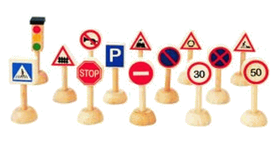
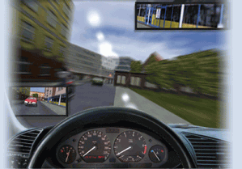 | To drive Conduire  Driver Conducteur  Occupant Passager  To start up Démarrer  To speed up Accélérer  To slow down Ralentir  To change down Rétrograder  To stop S'arrêter
Exercice :mettre le mot qui convient a la place qui convient :traffic light,zebra crossing,toll /turnpike,level crossing,main street,roundabout,road map,traffic-jump,pavement,parking meter

1. 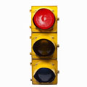The …………………………….is red, I must stop my car.
2. 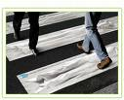In order to cross the street you'd better use the……………….
3. 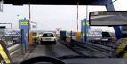Do you have some cash? we are arriving at the ………………
4. 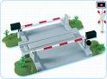The …………………..is closed, the train is not far from here.
5. 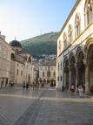The ……………………of this village is a pedestrian one.
6. 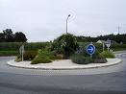On the ……………you will take the first right road, I'll be there waiting for you.
7. 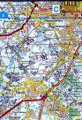Could you show me the right way on the………………….., please ?
8. 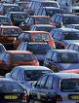Sorry I am late, I was stuck in a………………………………………..
9. 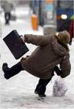Take care! the snow makes the ……………………………slippery.
10. 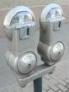I found my car back in the pound , I forgot to put some money in the……………………………………………..

